**AI (ML DL) May4**

**Project**

**On**

Predicting Compressive Strength of Concrete

Using

Machine learning Algorithms

By Team 17

1) Ardhani Vijay

2) Satya Dudi

3) Venna Sasidhar

4) Vinay varma

**Table of Contents**

|  |  |  |  |  |
| --- | --- | --- | --- | --- |
| **1** | |  | **INTRODUCTION** | |
|  | |  | 1.1 Overview | |
|  | |  | 1.2 Purpose | |
| **2** | |  | **LITERATURE SURVEY** | |
|  | |  | 2.1 Existing problem | | |
|  | |  | 2.2 Proposed solution | | |
| **3** | |  | **THEORITICAL ANALYSIS** | |
|  | |  | 3.1 Block diagram | |
|  | |  | 3.2 Hardware / Software designing | | |
| **4** | |  | **EXPERIMENTAL INVESTIGATIONS** | | |
| **5** | |  | **FLOWCHART** | |
| **6** | |  | **RESULT** |  |
| **7** | |  | **ADVANTAGES & DISADVANTAGES** | | |
| **8** | |  | **APPLICATIONS** | |
| **9** | |  | **CONCLUSION** | |
| **10** | |  | **FUTURE SCOPE** | |
| **11** | |  | **BIBILOGRAPHY** | |
|  | |  | **APPENDIX** | |
|  |  | | A. Source code | |

1. **Introduction** 
   1. **Overview:**

Concrete is a complex composite material. Compressive strength or compression strength is the capacity of a material or structure to withstand loads tending to reduce size, as opposed to tensile strength, which withstands loads tending to elongate.

The predictability of concrete properties is extremely low. Therefore, it is challenging to model the concrete properties according to the effect variables. The biggest challenge of experimental designs is a high number of effect variables affecting the response variables. Multiple effect variables increase the number of trials and it is difficult to obtain the real response function.

Generally, the one-factor-at-a-time method is used in experimental designs to determine the concrete properties. The major disadvantage of this approach is that it does not consider the interaction between the factors (interaction terms). The higher the number of the controlled and uncontrolled effect variables that influence the concrete properties, the lesser the predicted accuracy.

* 1. **Purpose:**

To predict the concrete strength of using the composition of its mixture and age of the concrete. Concrete has been widely used in recent years because its production compliments environmental conservation. It is a standard industrial practice that the concrete is classified based on grades. This grade is nothing but the Compressive Strength of the concrete cube or cylinder. Cube or Cylinder samples are usually tested under a compression testing machine to obtain the strength of concrete. The test requisites differ country to country based on the design code.

In recent years, the ML methods have become popular as they allow researchers to improve the prediction accuracy of concrete properties and are used for various engineering applications. The ML methods have been used to increase the prediction accuracy of concrete properties, and the data derived from the literature sources were used

Regression models tend to be used for the prediction of the compressive strength of high-strength concrete. These models also demonstrate how the concrete compressive strength depends on the mixing ratios.

1. **Literature Survey**

**2.1 Existing Problem**

In earlier days, the concrete strength is measure through other traditional methods like using drill holes, weight spring, or using sensors. But that requires a significant destruction of test sample and thereby increasing the cost. And the accuracy was also hardly 70%.

This is generally determined by a standard crushing test on a concrete cylinder. This requires engineers to build small concrete cylinders with different combinations of raw materials and test these cylinders for strength variations with a change in each raw material. The recommended wait time for testing the cylinder is 28 days to ensure correct results. This consumes a lot of time and requires a lot of labour to prepare different prototypes and test them. Also, this method is prone to human error and one small mistake can cause the wait time to drastically increase.

**2.2 Proposed Solution**

With the use of Machine Learning Model, there will be no limitation of the complexity increasing number of variables. This Model and train and test the given population of concrete and with the best performing machine learning model it can effortlessly predict the strength of the concrete with much higher accuracy than traditional methods.

1. **Theoretical Analysis**

**3.1 Block Diagram**

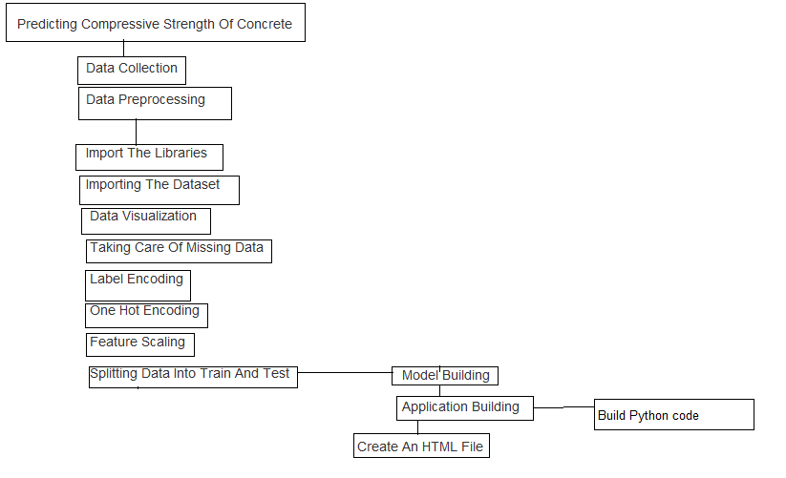

**3.2 Hardware / Software designing**

Python, Python Web Frame Works, Python for Data Analysis, Python For Data Visualization, Data Pre-processing Techniques, Machine Learning, Regression Algorithms

1. **Experimental Investigation**

During our investigation, we got to know all the required parameters to predict the concrete strength and we also analyzed different models and concluded the best model for predicting the output

1. **Flowchart**

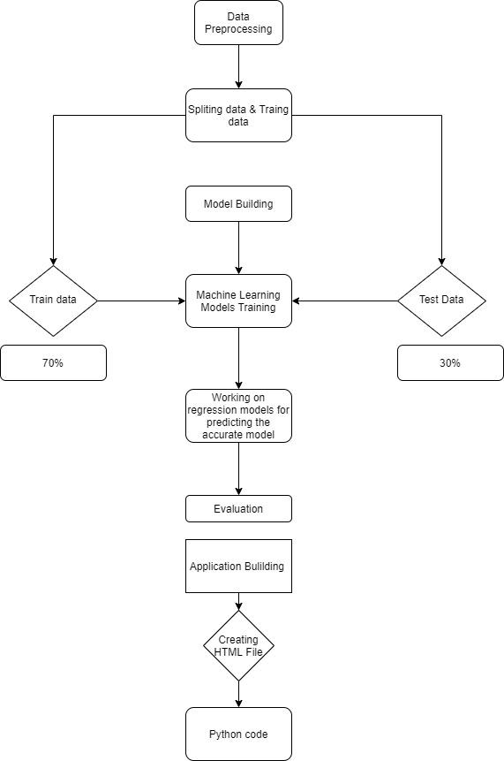

1. **Result**

We have analysed the Compressive Strength Data and used Machine Learning to Predict the Compressive Strength of Concrete. We have used Linear Regression and its variations, Lasso, Ridge and Random Forests to make predictions and compared their performance. Random Forest Regressor has highest accuracy and is a good choice for this problem. Random Forest Regressor trains randomly initialized trees with random subsets of data sampled from the training data, this will make our model more robust

1. **Advantages and Disadvantages**

**Advantages:**

* + Unlike traditional methods there is no wastage of test samples.
  + Higher accuracy can reduces errors in wrong grading of concretes.
  + Reduce the cost of finding out strength of concrete.
  + Engineers might also be able to play around with the composition and mixture quantity and understand the desired outcome of the concrete strength.
  + Easy user interface with straight forward prediction.

**Disadvantages :**

* The model is limited to predict the concrete strength for only those concretes which have exactly 8 compositions in their mixture.
  + The construction mixtures of the concrete needs to be accurately found out before any prediction of concrete strength.

1. **Applications:**

* Can predict the strength of the concrete using the inputs provided.

1. **Conclusion:**

Since nobody working on the concrete strength do not want to waste any of the physical resources for testing purpose our application helps in predicting the Strength of the concrete based on the past data

1. **Future Scope**

This model can predict the outcome with many different inputs within seconds. The model will save a lot of time of the construction companies and the civil engineers. Experiment cost is also reduced with creates a bigger opportunity for construction companies in cost effectiveness work.

1. **Bibliography**

**Model Building**

* Dataset
* Notebook

**Application Building**

* HTML 5 and CSS 3 files
* Flask
* Joblib

1. **Appendix**

Source Code :